CARESTREAM HEALTH
Change History
Revision | Description of Change | Revision Date
0.1 | Initial draft | 3/15/2015

Table of Contents
1 Introduction 3
1.1 Purpose 3
1.2 References 3
1.3 Acronyms 3
2 Installation 4
3 Software Usage Introduction 5
3.1 Start and Stop Virtual Lab System 5
3.2 OTC Buttons 6
3.3 WSD Buttons 6
3.4 TBL Buttons 7
3.5 Positioner Movement Control Buttons 7
3.6 Detector Control Buttons 8
3.7 Grid Selection 8
4 Examples 8
4.1 Auto Center OTC to WSD 8
4.2 Auto Positioning 9
4.3 Eject detector 0x01 from WSD and insert into TBL 9

Introduction
  - Purpose
The purpose of this document is to introduce the virtual evolution lab system GUI software installation and usage.

  - References
Below list the essential related documents used as sources of information, as a basis for understanding, and/or as origins of specific requirements.
Documents | Part Number | Revision
Virtual Evolution Lab System Software Installation and Configuration Guide |  | 1.0
Virtual Evolution Lab System Hardware Installation and Configuration Guide |  | 1.0

Acronyms

Abbreviation | Meaning
GUI | Graphic User Interface
CAN | Controller Area Network
GUI | Graphical User Interface – What the end user sees.
WSD | Wall Stand Axis Controller
TBL | Table Axis Controller
OTC | Over Tube Axis Controller
PCU | Power Control Unit

Installation
1. Run “Setup” execution file of virtual lab system.
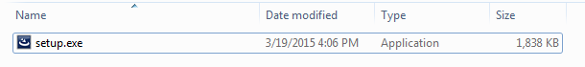
2. Click “Next” button to finish the installation.
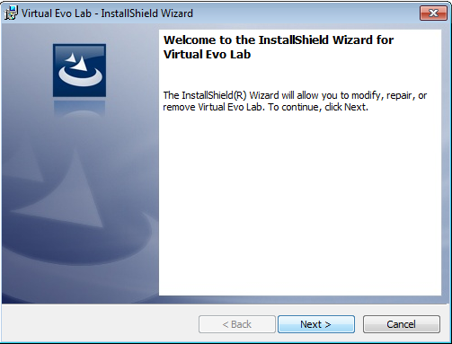
3. There will be a shortcut on desktop.
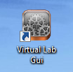

4. Click the icon to run virtual lab control GUI.
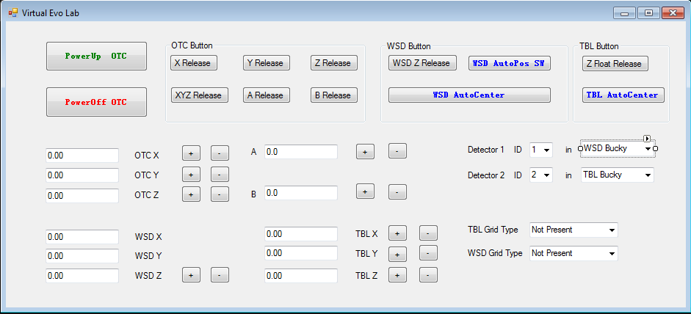

Software Usage Introduction

Start and Stop Virtual Lab System
Click the “PowerUp OTC” and “Poweroff OTC” buttons to start and stop the system
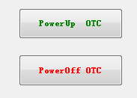
When the application is running, UPS simulator is always running to keep heartbeat with console. “Powerup” and “Poweroff” will start all axis controllers and collimator simulators.

OTC Buttons
OTC buttons on GUI are mapping to real OTC hardware buttons.
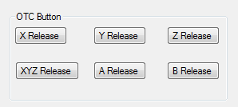
X Release: Release the OTC X axis brake.
Y Release: Release the OTC Y axis brake.
Z Release: Release the OTC Z axis brake.
XYZ Release: Release the OTC X,Y and Z axis brake.
A Release: Release the OTC alpha axis brake.
B Release: Release the OTC beta axis brake

WSD Buttons
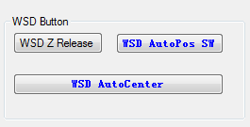
WSD Z Release: Release WSD Z axis brake.
WSD AutoPos SW: Press the button to start auto position function.
WSD AutoCenter: Press the button to start OTC auto center to WSD function.

TBL Buttons
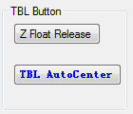
Z Float Release: Release table Z float brake.
TBL AutoCenter: Press the button to start OTC auto center to TBL function.

Positioner Movement Control Buttons
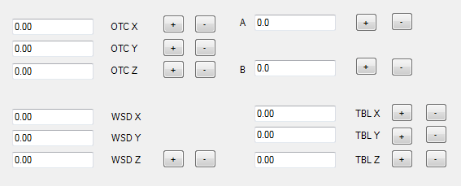

User could use these to move OTC, WSD and TBL to the position they expected (Note: position value limits will be not checked here).
“+” will increase the value of axis position, “-” will decrease the value of axis position.

Detector Control Buttons
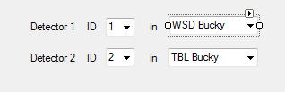

Detector control button is used to set the detector id and the Bucky type.
There could be 1 or 2 detectors in system, if select “None” from the Bucky type selection box, the detector will be ejected from Bucky.
Detector id could be number 1-8;

Grid Selection
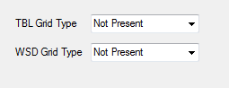
Grid selection boxes are used to select the grid type of WSD and TBL.
There’ll be no grid in WSD and TBL by default.

Examples

Auto Center OTC to WSD
1. Click “PowerUp OTC” to start the virtual lab system.
2. Click “WSD AutoCenter” button to start auto centering of OTC
3. The OTC Screen will display that it’s performing auto centering now.
4. When the auto centering is finished, release the “WSD AutoCenter” button.

Auto Positioning
1. Click “PowerUp OTC” button to start the virtual lab system.
2. Select a predefined position from the OTC touch screen.
3. Click “WSD AutoPos SW” button and OTC Screen will display the auto positioning is performing.
4. After auto positioning, release the “WSD AutoPos SW” button.

Eject detector 0x01 from WSD and insert into TBL
1. From detector 1 select box, select the detector id “1” and select the Bucky type “None”.
2. You could find the detector 1 is ejected from WSD Bucky.
3. From detector 1 select box, select the Bucky type “TBL”.
4. The detector is inserted into TBL Bucky, and you could select the detector from capture console.

